nmtbg- ONLINE
Issue 01 – http:markmonk72.tripod.com Autumn 2008

So wots this all about then?

No doubt many of you remember the fanzine from the early/mid 1990’s (memories of which were recently revived in Mark Monk’s book “There’s a light that never goes out”) then welcome to the 21st century version!
We will be putting out the usually vitriolic and semi-libellous commentary but ONLINE and for YOU to download for FREE!
You may print off the fanzine if you wish, or if you are feeling really green simply keep it on your hard-drive after downloading it for future reading.
So remember to bookmark http:markmonk72.tripod.com or better still, register your email address with us so you can be informed when the latest issue comes out.
And whilst you are on the website, why not check out some seriously funny material from past editions of NMTBG in the 1990’s.

Dicky’s boys in for Booky Bonanza!
New shirts courtesy of author and ex-boss!

Dicky Waldrum’s BGFC will soon be strutting their stuff at Hood Park with a fantastic new set of shirts, courtesy of Mark Monk.
Following encouraging sales of Mark’s book “There’s a light that never goes out”, Mark has donated a set of shirts to Dicky’s successful Five-A-Side team.
Mark said “It’s about the past looking after the future. Sales of the book were really encouraging during the first couple of weeks and it is the least I can do!”
However, the only drawback was that they are technically Wigan Athletic away shirts from the 2005/06 in yellow and navy! A far cry from the club’s traditional green and white strip!
If you have not got your book yet an order form can be found on page 4!!!
The Bowling Green FC will be strutting their stuff in erm…Wigan Athletic Shirts from the 2005/06 season

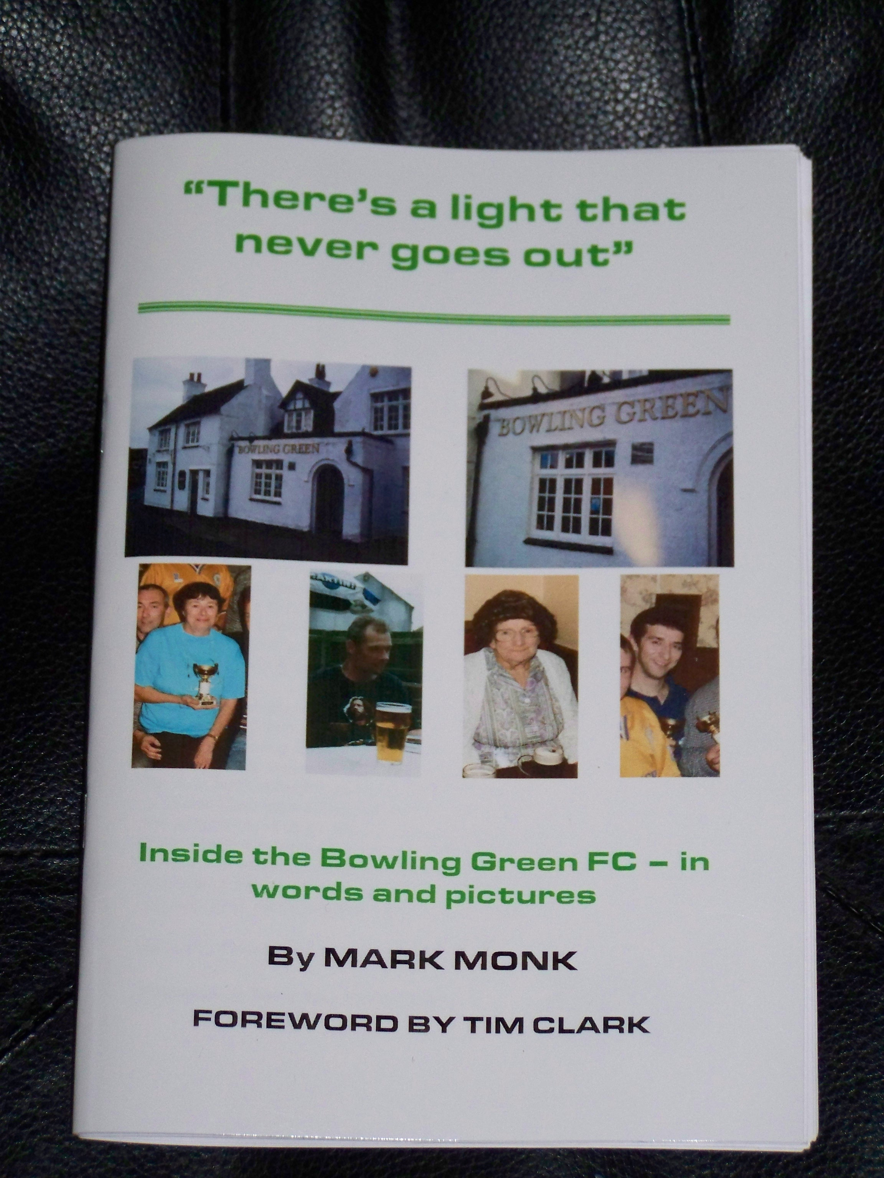

Inside This Issue
2 | Getting shirty
3 | Statute’s – what is it good for – absolutely nothing!
4 | Stylish BG thrash Dynamo 5-2
5 | Marko’s big day out at Wembley
Story continued on page 2

continued from page 1

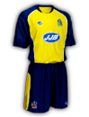
Getting shirty!!!
Generous act or sacrilege to our great tradition?

Mark Monk’s decision to supply the BGFC with a new kit will obviously be greeted with mixed feelings.

Following “record breaking” sales of his book “There’s a light that never goes out”, Marko has done the decent thing and rather than invest the proceeds behind the bar at the BG, he has given the lads a new kit.

However, the shirts supplied are Wigan Athletic away shirts!!! (pictured above) from the 2005/06 season.

Mr Monk was coy on how he came to have a full-set of Wigan shirts in his possession. All he would revealed was that he “came across them” whilst “passing through” the Lancashire town, which he added “was probably the best policy”.

But surely they break with tradition? A Bowling Green team, like the very early ones should wear green and white?

What do you think? Email Mark at markmonk@yahoo.com if you think he is a colourblind twat and has got it all wrong.

However Derby fan Dicky Waldrum was reportedly “delighted” with the shirts and confessed that “we will wear owt!”

Maybe Dicky will hope that wearing the Wigan shirts will bring the BGFC some much-needed luck at Hood Park, and possibly persuade Paul Jewell to piss-off back there!!!
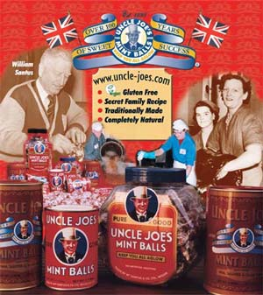

Some things you didn’t know/couldn’t be arsed to know about WIGAN

1- It is one of Lancashire’s oldest boroughs, having received a charter from Henry III in 1246.

2- It supplies the world with famous foodstuffs including Heinz baked-beans, patak’s curry sauces and Uncle Joe’s Mintballs (pictured above).

3- Rock legends The Verve met at Winstanley College near Wigan and are from the area.

4- Wigan Casino niteclub was the so-called “spiritual home of northern soul” until it burnt down.

5- Famous Wiganer’s or Pie-eaters as they are colloquially known include Sky TV’s Kaye Burley, ex-Corrie actors Georgia Taylor (Toyah Battersby) and Eva Pope (barmaid Tanya Pooley). The late George Formby, actor Roy Kinnear and ex-Miners leader Joe Gormley were also born here.

Wigan is 94 miles from Ashby-de-la-Zouch and would take you 1h 51 mins to get there. See www.wiganworld.co.uk for more info!

Statutes’ huh yeh! What is it good for? Absolutely nothing……

Oh uh! Its that time of year again folks! The dreaded one-way system is back and so are the Ashby Statutes!
The ancient order or statute, permitting pikeys I mean “trained professional showpeople” to section off Market Street and Brook Street and basically rip thousands out of mug punters off for four days officially begins on September 12th whopeededoo!
Having driven round the Ashby Orbital route (at just £1.10 per litre) for three hours, you too can struggle to find somewhere to park, then treat your family to an hour or two of fun, which will set you back a mere couple of hundred quid!
But rest assured, cash-machines are in abundance in Ashby – just hope and pray they have not been doctored by Ilie Berbatov and his Bulgarian mafia mates (currently living in Measham and fronting their operation as a car-wash!).
Marvel at the thrill and fun of the fair and basically get the feeling of déjà vu as it will probably be the same rides as last year and the year before and the year before that etc.
Take your own life into your hands on the daredevil attractions….eg buy a burger if you dare and feel the sensation as your life simply drains out of you and you feel the need to pass the world through your bottom.
Win quality prizes! Like squares of fake sheepskin rugs with a pair of cardboard eyes badly stapled to them or some plastic Chinese made mini toy car that the wheels will drop off by the time you finish getting round.
Or better still, stay in the pub and drink flat beer out of a plaggy glass with a wasp in it whilst watching the rain hammer down!
The statutes does bring out lots of totty, desperate for a romantic rumble with a gaff lad in a caravan, so grow that stubble, don that fake gold jewellery and scruffy sportswear and it could be your lucky night – but send the wife and kids home first!!!

JOE CROW JOKE!

Joe found a new job, like many Irish folk he worked in horse racing. One day the police stopped him on the A42 whilst he was driving a Horse Van on the way to the races.

“Where are you going Joe?” asked the copper.

“I’m taking these horses to Leicester races” Joe explained.

The copper looked in the back of the van. “But Joseph, the van is empty!” he said.

“I know!” said Joe, “But I’m taking the non-runners first!”

Remembering “Sickie”

I was quite sad to hear about the passing of occasional BG regular Brian Witton in July.

I worked with Brian between 1996-2001. Without wanting to speak ill of him, his attendance at work was a bit erratic and he was fondly known as sicknote. Unfortunately, it was part of my job back then to MFA (Management For Attendance) and me and Brian would often sit at opposite sides of the desk, I also had the unwanted job of having to make Brian redundant in 2001, but he took it with good grace and he shook my hand on that sad day. I would like to think that we still remained on good-terms despite me often being his nemesis.

I began to bump into him more regularly over the past couple of years in Ashby and we often shared a natter and a pint. As a man, I could not fault him, he was kind, generous with a heart of gold and a devoted Dad/Grandad. In 2000, he lost his wife Margaret in the most tragic circumstances when really they both should have been looking forward to a long and happy retirement.

How sad it is to hear of Brian’s passing and both I and Lesley-Anne have fond memories of him.

DICKY’S BOYS ARE JUST DYNAMITE!
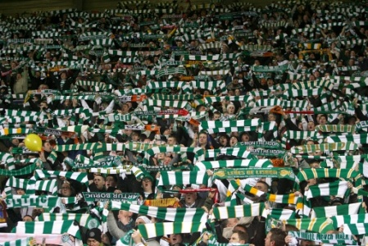

HOOD PARK DIVISION ONE – Sunday September 21st 2008

BGFC 4 DYNAMO 2

Dicky Waldrum’s BGFC got off to a flyer at Hood Park with an emphatic win over a well-organised Dynamo side.

Wearing their new kit courtesy of Mark Monk’s literary ventures, the Green may have at first been rueing the decision to don the new shirts against their young opponents, when they fell behind two-goals early doors.

However it was the highly rated Waldrum junior Quig who led the fightback, firing in two quick goals, the BG edged in front thanks to an Itchy Hanslow screamer and the veteran Waldrum proved there is life in the old dog yet with the BG’s fourth!

The much-talked about controversial Wigan shirts have got off to a flyer and we hope they bring the team even more good luck in the near future.

“THERE’S A LIGHT THAT NEVER GOES OUT” ORDER FORM.

Dear Mark

Please rush me ______ copies of your book.

I enclose £2.50 per book (payable to Mark Monk)

Name:

Address:

Please post to 85 Bosworth Rd, Castle Donington. DE74 2JN.
CONTRIBUTE!
EMAIL markmonk@yahoo.com any articles, suggestions, cartoons!

WHY NOT SHARE YOUR ANNOUNCEMENT WITH US? – WE WILL MENTION IT IN THE NEXT ISSUE FOR FREE!

Glory Glory M** U****d!
- the Mark Monk column

I know, I still struggle to comprehend it too, but on Sunday
August 9th 2008, any unsuspecting innocent bystander may
have mistook me for…..a Manchester United fan!

Anyone who knows me will know that I am a diehard fan of
the real United – Leeds! Even though we are two divisions
below the scum from Old Trafford these days, we still hate
them with a passion. Most people who follow football even on a casual basis will know that Leeds and Manchester United fans have never got on. The rivalry was intense during the 1990’s, much to my own shame and disgust some Leeds supporters would taunt Manchester United fans about the Munich air-crash in 1958. In 2001, Manchester United fans responded with a banner taunting Leeds supporters about the death of the two Leeds supporters who were killed in Istanbul before the 2000 UEFA Cup semi-final against Galatasary.

So in 2004, when the mighty Leeds did the decent thing and bowed out of the Premiership to give the other’s a chance (and repeated this gesture in 2007 by dropping out of the Championship into League One) I suspect the chief constables of West Yorkshire and Greater Manchester breathed a huge sigh of relief.

However one of my pals from university James, a Notts County fan with Man United sympathies told me he had got a spare ticket for the Community Shield, I accepted. He’s a good lad, despite that red flaw on his character and by the time we reached St Pancras, I was a little giddy having consumed an obscene amount of cheap French lager Id imported from Eastenders, Calais a few weeks earlier.

We took the tube to Wembley Park, so we could walk up Olympic Way. Having missed out on the League One play-off final last season (when Leeds monogamously let little Doncaster win), this was the first time I had seen the new stadium since it was rebuilt. Although it does not have the character of the old Wembley, it is a spectacular arena and having been sceptical about “the arch” (mainly because I understand it was Ken Bates idea!) I must admit it sets off the perfect arena for football. Although I miss those crumbling twin-towers and algae stained glass roof’s of the old Wembley, I am converted.

However, I needed another pint (£3.00 for a flat pint of Carlsberg in a plaggy glass which had been poured about half an hour earlier) because the tickets were in the Manchester United end. As I rubbed shoulders with the hordes of reds, many of them with cockney accents, I thought about all the titanic battles between us and them down the years, of being kept in at Old Trafford for half an hour after the final whistle, the army of riot policemen at Elland Road when they have been to Leeds etc etc etc. To be fair, I don’t have that much more time for Portsmouth who were Manchester United’s opponents that day.

The game was appalling, it was a relief when the final whistle came and it was straight to penalties rather than extra-time. Man United won and there was me, impassively arm’s folded, refusing to clap, cheer or anything when the victorious team were awarded their medals – it seemed to take them ages to get to the royal box. Thankfully James just wanted to see the presentation and we were out in the fresh-air, where we were drenched by icy rain, soaked to the skin, even that was more preferable than spend another minute surrounded by Man United fans!

A traumatic tube journey back to St Pancras and a quick pint in the Irish pub over the road and then to Burger King before the best part of the day! James informed me that his Grandparents, his Grandad being an FA Council Member were going back on the same 8pm train. His Grandad kindly paid for us to be upgraded to first-class and then his Grandma gave me two bags, stuffed with four commemorative football’s they had been given by the sponsors, one of which was signed by Fabio Capello – for my sons. I was shocked to say the least, that these two people, only known to me through my good mate, had gone to so much trouble on my behalf.

James’s Grandad was fascinating company, in his early 70’s he recoiled many football stories and had an amazing ability to recall actual dates of events. The two and a bit hour journey back to Nottingham Station flew by and on leaving the station, the old feller said to me “Now you have seen the best team in the land, maybe you will want to see them more often instead of Leeds?”

No chance! But in a way, I cannot wait to see Manchester United again…..when Leeds are the opponents of course and the next time, I will be sitting in the right end!!!

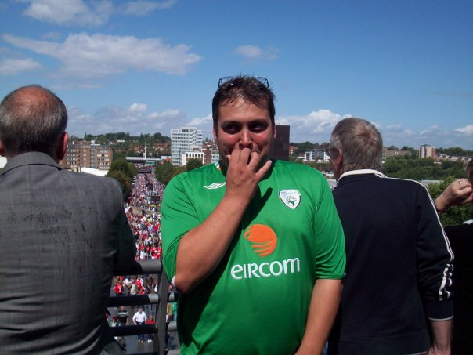
Me basically shitting myself at Wembley

